Item No | LV1109.1/ LV1109.2/ LV1109.3
Power Consumption | 9W
Total Lumens | 700lm
Input Voltage | AC100-240V
Output Voltage | 37V
Current | 240mA
LED module(COB) | Sharp
CRI | >85
Power Factor | >0.95
Beam Angle | 20°/ 36°/ 50°
CCT | 3000K / 4000K / 5000K
IP Rate | IP20
Materials | Aluminum alloy
Life span | 50000 hrs

Product Dimensions

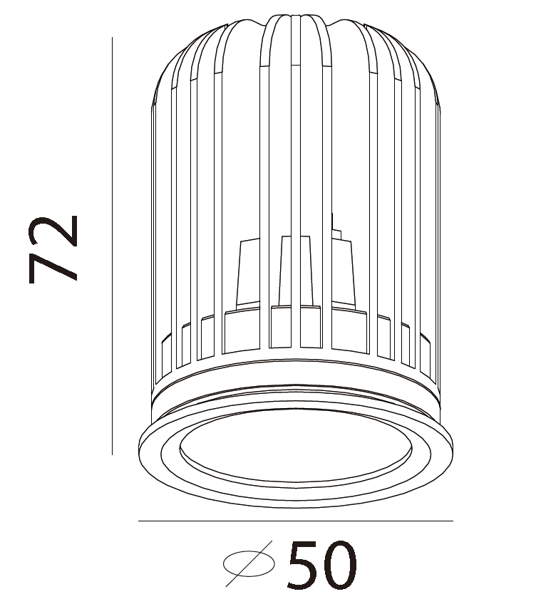

Lumination distribution curve:
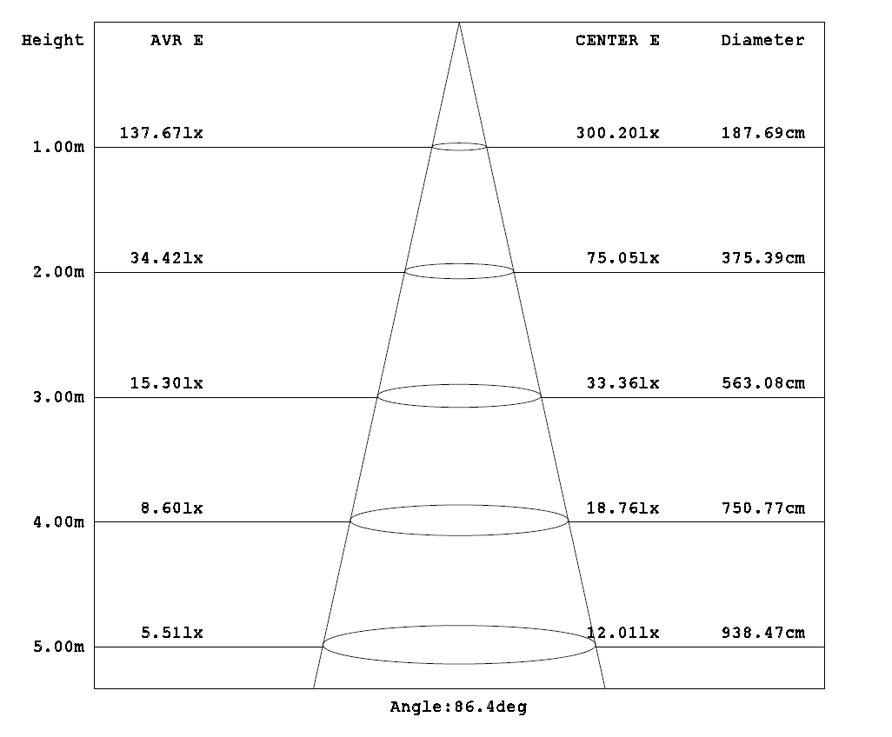

Applications:
1. Replacement for traditional recessed lights
2. Ceiling light
3. Shopping center
4. Walkway
5. Hotel
6. Restaurant
7. Entertainment places
8. Display case
9. Museum
10. Household

